**2D Engine Development CA1**

**What we did.**

**Patricia Bere:**

* In charge of asset gathering and creation.
* Implemented sprites into finished tech – i.e. backgrounds in parallax, etc.
* Created player character sprite sheets with the assistance of “Game Character Hub” on steam - <http://store.steampowered.com/app/292230/Game_Character_Hub/> - Many of the sprites have been created from these as a base, i.e. character hit sprites.
* Created Longhouse sprite.
* Gathered sprites for:
  + Parallax background
  + Foreground
  + Bush
  + Log
  + Bird
  + Boar
  + Bull
  + Temple
* Gathered and edited the background music <https://youtu.be/lj2Ehv21VGQ>
* Helped with the css and making bird script
* Testing

**Oisin Murphy:**

* Created player character functionality and controls – movement, jumping, attacking, hit-detection, collisions, falling, etc.
* Created background image tech allowing for parallax scrolling on user input.
* Created all object arrays and renderCanvas operations.
* Created endGoal script.
* Created obstacle script.
* Created decoration script.
* Created pitfall script.
* Helped with bird script
* Placed objects, enemies, decorations, pitfalls and the ending around the level.
* Testing

**Ben Watt:**

* Created enemy scripts – boar, bull & crocodile.
* Assisted with background image tech.
* Created a test layout of the level with the use of drawings.
* Placement of Enemies and objects, start & end, pitfalls, decorations.

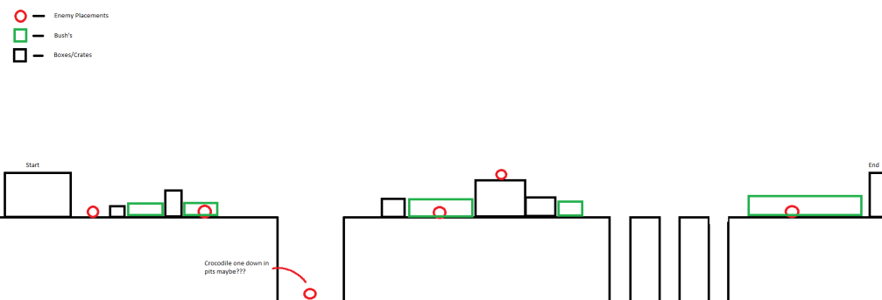

* Imported and placed bush sprites around the environment.
* Testing.